**SMART PESTICIDE BLENDING SYSTEM**

Sri Chetan MKM Nawaz Sathwik Goud

(20071A6938) (20071A6940) (20071A6944)

Department of Computer Science-Internet of Things

VNR Vignana Jyothi Institute of Engineering and Technology

**ABSTRACT**

In this era modern technology the population around the world has been increasingly rapidly . As the population is increasing the need of food production is also increasing . And to meet the food production the farmers are using fertilizers and pesticides to increase the production . But the farmers don’t have mush knowledge regarding how much quantity of pesticides need to be mixed with amount of water. Apart from the other requirements in the agricultural sector, pesticides mixing is one of the basic requirement that is necessary . If this is not done properly then it may lead to the lose of the fertility of soil in long term use. Then the soil can never be used for farming even if we use any kind of pesticides and fertilizers .So, to prevent this kind of scenarios and to increase the food production we developed a system that mixes pesticides and water and you don’t need to have much knowledge . You just need to enter the name and the amount of pesticides. We can enter the amount of pesticides that we need through Blynk it app (IOT platform ) over Wifi .As it don’t require any hard physical work farmers will be getting benefit from it .In this proposed system node-MCU integrates with the relay to control sensors and motors.

**Keywords:** Nodemcu, Blynk, Sensors, Motors.

# 

# INTRODUCTION

Nowadays, technology is flourishing at a very fast rate . We have seen introducing the technology in agriculture sector through means of irrigation. Our proposed system is quite different from irrigation and it is more than that . It might sound different but we can see the results when we implement it practically. The primary focus of the proposed system is to ease the work in agricultural sector. The existing technology in agriculture just eases the work in irrigation sector. But we haven’t seen technology that is focused on mixing the pesticides . In our research we have identified the following problems because of technology that is not used in mixing :-

* + - * + **Human Health:**Intake of foods that are yielded through using huge amount of pesticides will effect health of human effectively. Humans can be effected with the diseases like Cancer ,Allergy ,Asthma because of the high usage of pesticides in agricultural sector. So, it’s important to maintain the pesticides content in agricultural sector.
* **Insects :** Over usage of pesticides can impact on the life of the local insects .Not only the local insects but also the earthworms and other insects that live in soil and help farmers in farming directly or indirectly
* **Environmental pollution:**over usage of pesticides can contaminate the underground water which are used by local people for various purposes like irrigation , and drinking .
* **Fertility of soil:**If pesticides ate used for longer time (can be over for years ) then the soil will lose its fertility and it can no longer be used for agriculture which will adversely effect farmer in long-term.
* **Pollination :**Pesticides reduce the yield of crop because it affects the natural pollination done by bees and butterflies .
* **Production yield :** We will not be able to get enough production of food grains which leads to financial loss.

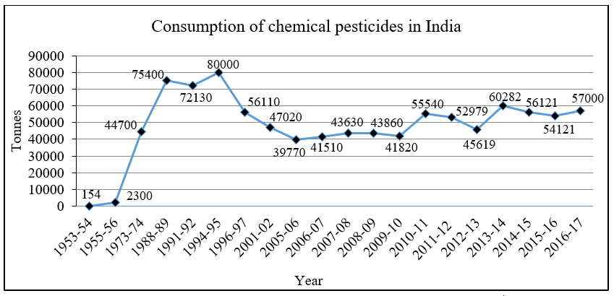

***Fig -1***

* The above graph depicts the usage of pesticides of India over the decades.
* We can see that the graph is not linear , as the usage is increasing and decreasing .
* The reason behind is not having proper knowledge about pesticides
* Our proposed project overcomes this scenario which helps the farmers to get high yield .

## RELATED WORKS

This paper describes system consisting of Nodemcu, Ultrasonic sensors, Pump motor to develop smart pesticide mixing system.

* This system can be used to mix the pesticides manually from mobile application Blynk.
* The farmers do not get harm from dangerous chemicals while mixing this system as they are not mixing physically.
* The liquid level of water and the liquid level of pesticides can be monitored using the Blynk application.
* After mixing of the pesticide and water it will automatically spray to the fields using pump motor.
* After completion of the whole process it will be notified with the alert sound and with blinking of LED on mobile application

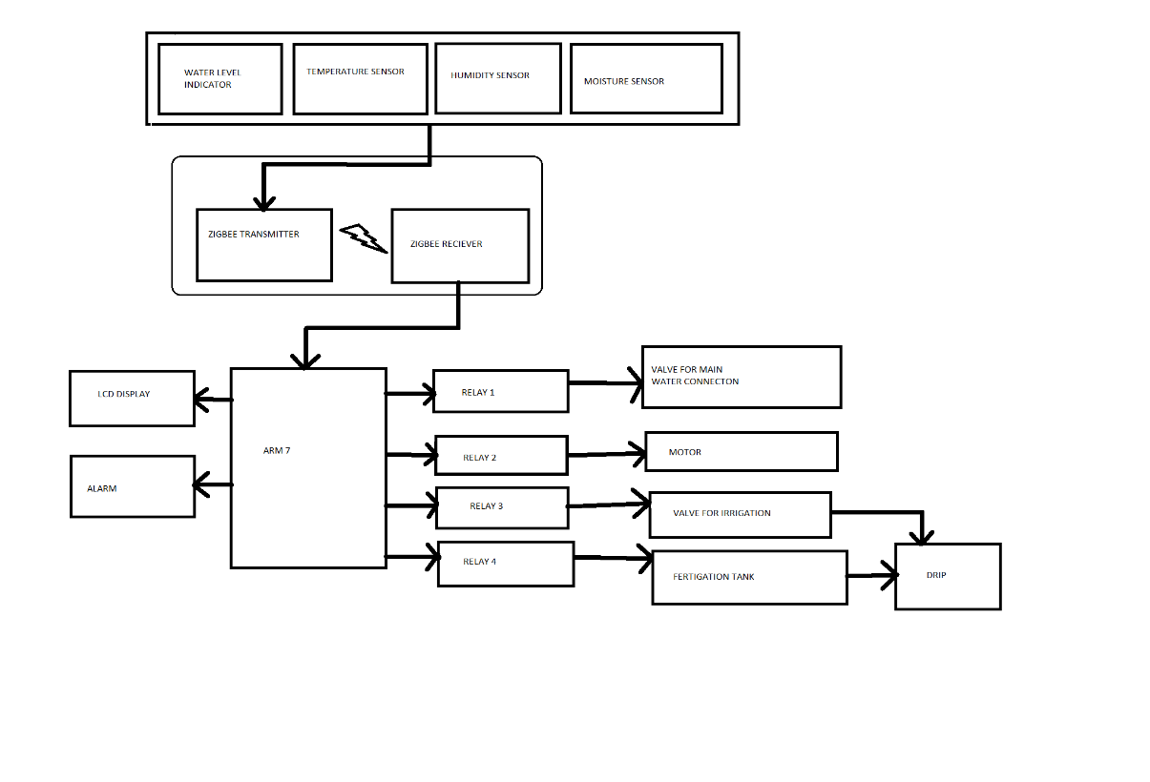

***Fig 2***

**The above figure 2 is the complete block diagram of our proposed system.**

The proposed system consists of three containers which are connected with connecting pipes. Each container is having a ultrasonic sensor and a pump motor to extract water from one container to another container. All these components are connected to the Node-MCU microcontroller where the code and logic is dumped into it. Firstly, we need to enter the required amount of pesticide (in liters) in the Blynk application. And it will take the water based on the amount of pesticide which has been entered earlier. The pesticide and water are sent to the third container in which these liquids are mixed thoroughly using motor and later it is pumped in to the field. This is the whole process of the smart pesticide mixing. The user can also monitor the liquid level of the pesticide and water in the Blynk application and after completion of the whole process the user gets a notification alert or it will blink LED in the Blynk application. And the other software used is Arduino IDE for writing the code for the whole system.

## 

## HARDWARE AND SOFTWARE

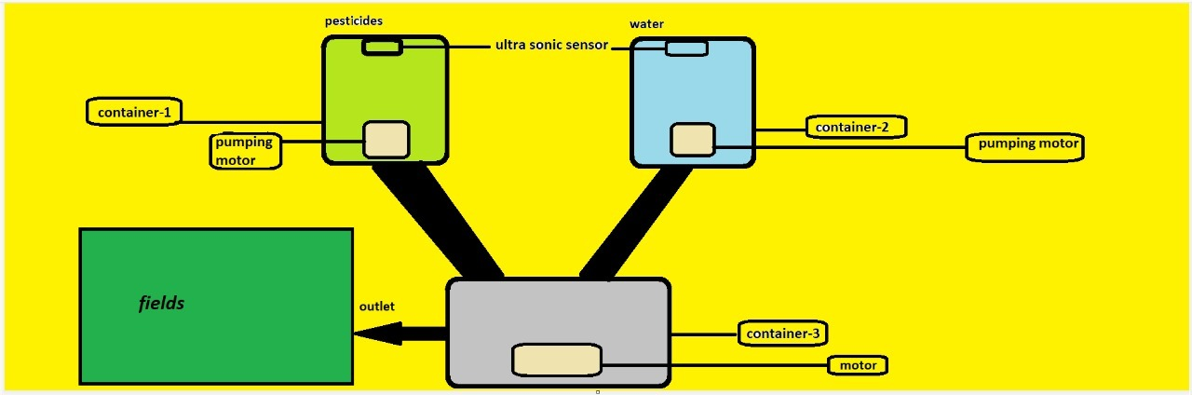

***fig 3***

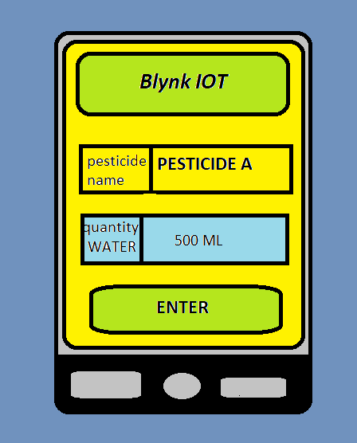

***Fig 4***

Our Proposed system requires the following hardware and software components:

**Hardware:**

1) NodeMCU

2) Ultrasonic Sensors

3) Pumping motor

4) Connecting pipes

5) Containers

6) DC motor

7) Connecting wires

8) 4-channel relay module

**Software:**

1) Arduino IDE

2) Blynk IOT application

**NODE MCU:**

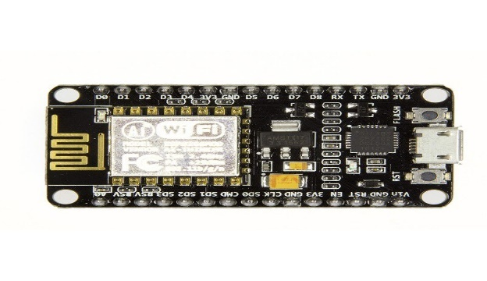

***fig- 5***

NodeMCU is a microcontroller board , used for developing IOT based products. UART,SPI and I2C are the interfaces that are supported by NodeMCU.

Clock frequency ranges from 80MHz to 160MHz.For storing data and programs NodeMCU has 128KB of Ram and $MB of flash memory. It uses Lua scripting language and it has inbuilt Wi-fi module, general purpose input and output pins. It is built around very cheap SoC (System on chip) i.e. ESP8266 with high processing capability and can be powered using USB jack .Ultrasonic sensors ,Pumping motors , Rotating motor are connected to Node MCU board through relay .

**ULTRA SONIC SENSOR:**

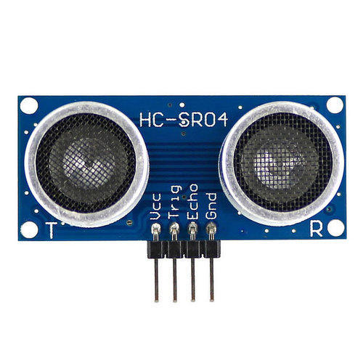

***Fig 6***

Ultra sonic sensors are used to measure the distance from the position where it is placed . In our proposed project these are fitted on the top of the containers in which pesticides and water are placed . As the width of the container is fixed , the volume will be measured in terms of height(internally).We will be using 2 ultra sonic sensors of which one will be placed on the top of the pesticide container and the other on top of the motor container.

**PUMPING MOTORS:**

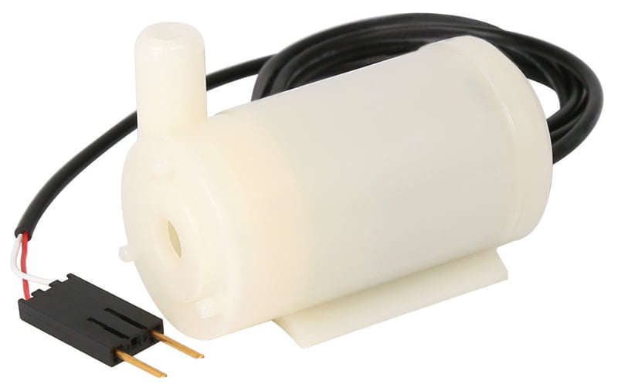

***Fig 7***

The purpose of the pumping motors is to pump the water/liquid .Similar kind of requirement is there in our project. The pesticides and the water will be pushed out of the containers using these pumping motors , So we would be using 3 pumping motors in which the third is used for outlet of the whole system. These pumping motors are connected to the relay which controls the whole ecosystem .

**RELAY MODULE:**

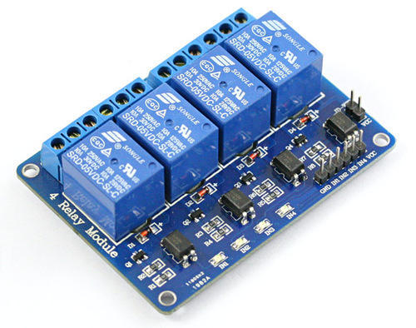

***Fig 8***

Relay is an electro mechanical switch which is operated by an electro magnet. .A low power signal is required from micro controller to activate the electromagnet .When the electro magnet gets activated it either closes or opens an electric circuit. This relay module not just acts as a mediator between the node MCU and the other components but controls them

**ARDUINO IDE:**

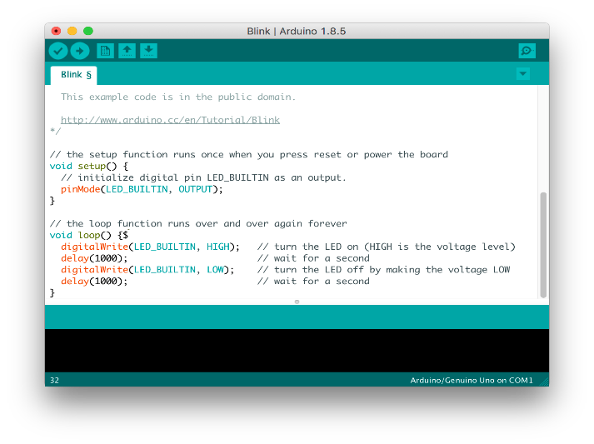

***Fig 9***

Arduino IDE is a software where we can write, code and upload programs on micro controller. Sensor libraries can be uploaded to the arduino Ide. Programs are written in C and C++ language .We will be writing the whole program in this Arduino IDE which is the basic requirement for the system. The program will be interlinked with the node MCU which is later connected to the relay module.

**BLYNK-IOT Platform:**

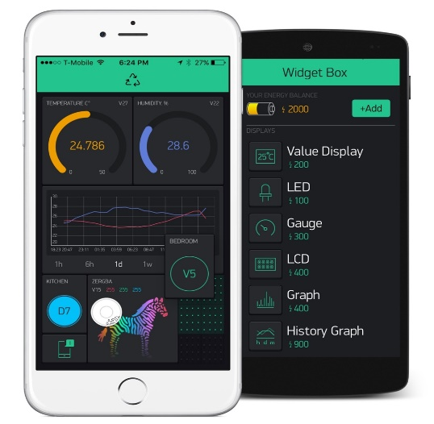

***Fig 10***

Internet of Things(Iot) is a booming technology that connects various things around us through internet or simply we can say Smart things .When we want to connect our system to mobile we need some intergace through which we can control the system from any wgere round the world. Blynk is such a platform through which we can connect our system to it and perform various operations rihjt from the mobile itself .Blynk platform is very easy to understand and we could connect our system to the internet through blynk very easily which is very difficult in other platforms like UBidots.We would be entering the amount of pesticide that we need and when we enter that amount of pesticide and the default amount of water will be pushed into the third container which can be later used for spraying. Internet of Things (IoT) is the organization of actual articles fit for moving information over network with no manual or framework obstruction. Blynk is an Internet-of Things based stage created to make brilliant IoT things. It tends to be utilized to peruse, store, and imagine sensor information and furthermore to remotely control equipment. The accompanying are the means continued in making portable application. Download the Blynkapp and make a Blynk account. After login, make new Project in that. Pick the equipment on which you are dealing with. The Auth Token will be ship off your record. Add Gadget from the Widget Box. Run The Project. At the point when saline jug is going to discharge, Hub MCU sends the warning to the specialist or medical attendant through versatile application. The patient subtleties and stream rate are likewise kept in the portable application; It is shown in understanding room and control room show

# PROJECT SETUP

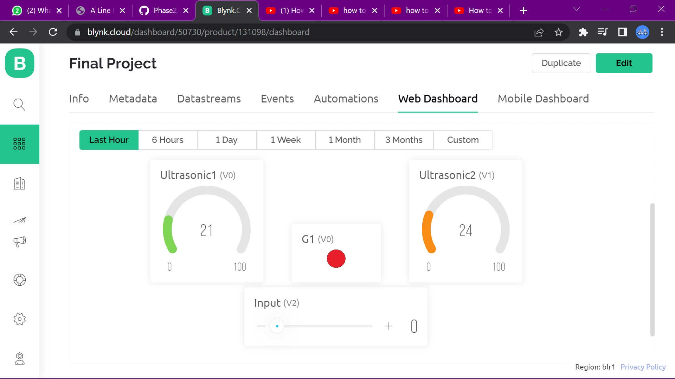

***Fig 11***

The above fig 4(b) shows how the interface will be . The scroller which is given the description as input is the place where we enter the value . The ultrasonic sensors values change as the flow progresses into the third container .The ultra sonic sensor 1 is for the container which shows the flow/amount of pesticide and the ultra sonic sensor 2 is for the second container which contains the water

# KEY FEATURES OF THIS PROJECT

* We can control our gadget from anywhere round the world by just tapping on Blynk through mobile.
* We will be able to get complete health data on crop .
* We can know the humidity in air, moisture content in soil through which we dry the soil is and how much water can be supplied to it.
* Using the above values as base conditions / reference values our system will be able to calculate the amount of water it requires and it allows the flow of water -only that amount of water its necessary to the fields.

# RESULT

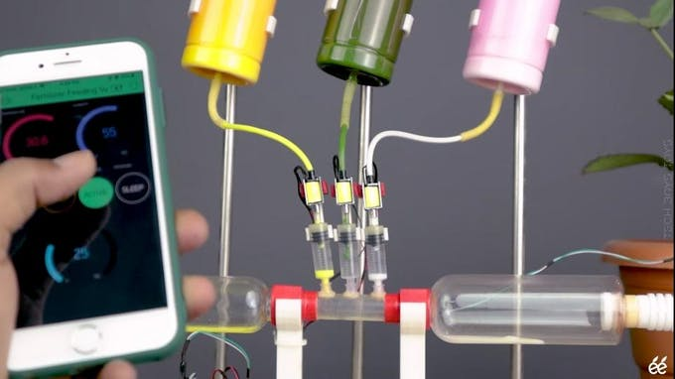

***Fig 12***

The above is an ideal picture where one can enter the amount of pesticide that are required through blynk IoT application . As soon as he enters the values the system gets into work , the amount of pesticide and the amount of water will move simultaneously into the third container . When the entered values/amount are pushed into the container the system will stop its working i.e. , the pumping motors and ultra sonic sensors will stop their work and now the rotating motor will start its work , mixing both the water and pesticide .Then it can be used through an outlet and irrigate it for fields.

# CONCLUSION

Our proposed system reduces burden on farmers of how to mix the pesticides and usage of pesticides in a very effective way which is completely different from the innovations that are made on agriculture sector .Their effective usage helps in better yield of crops , reduces the adverse effects of pesticides on nature which is a very positive factor in long term use .It also reduces the economical burden on farmers which is not done by other innovations made in agriculture sector.

# References

* Overview of ESP8266 Wi-Fi module based Smart Irrigation System using IOT(Published in: 2018 Fourth International Conference on Advances in Electrical, Electronics, Information, Communication and Bio-Informatics (AEEICB))
* A Smart Irrigation System Using IoT and Fuzzy Logic Controller(Published in: 2018 Fifth HCT Information Technology Trends (ITT))
* A Review of IoT based Smart Farm Monitoring(Published in: 2018 Second International Conference on Inventive Communication and Computational Technologies (ICICCT))
* Development Strategies and Prospects of Nano-based Smart Pesticide Formulation
* Mobile integrated smart irrigation management and monitoring system using IOT(Published in: 2017 International Conference on Communication and Signal Processing (ICCSP))
* Study on Online Mixing Pesticide Technology and Automatic Control and Detection of Concentration
* An Innovative Approach to Control Pesticide Sprayer Using Solar Based Bluetooth Device
* Internet of Things Based Pest Management Using Natural Pesticides for Small Scale Organic Gardens
* Garden Monitoring System and Controlling Pesticide Using IoT
* Nano-based smart pesticide formulations: Emerging opportunities for agriculture